LAB 4

Q1.)
While tcpdump host your_host is running in one command window, run ping 127.0.0.1 from
another command window. From the ping output, is the 127.0.0.1 interface on? Can you see any
ICMP message sent from your host in the tcpdump output? Why?

sudo tcpdump -i enp2s0 host 127.0.0.1

The interface is set to ethernet, and then ping, then no ICMP messages are seen. This is because you are creating a loopback, but listening on the hardware level. If the interface is set to ethernet, then you will only see those packets which cross the physical ethernet interface.
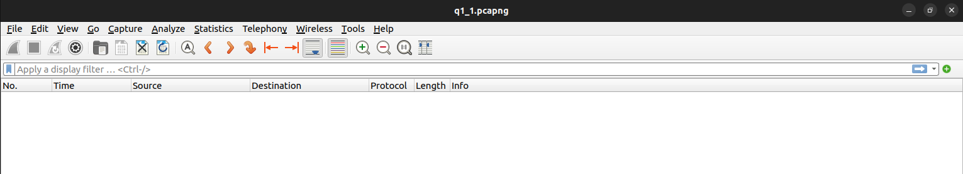

sudo tcpdump -i lo host 127.0.0.1

The interface is set to loopback
ICMP echo requests and replys are seen in the dump.
The loopback interface (lo) is a logical interface, and you can only see loopback messages when using this interface.
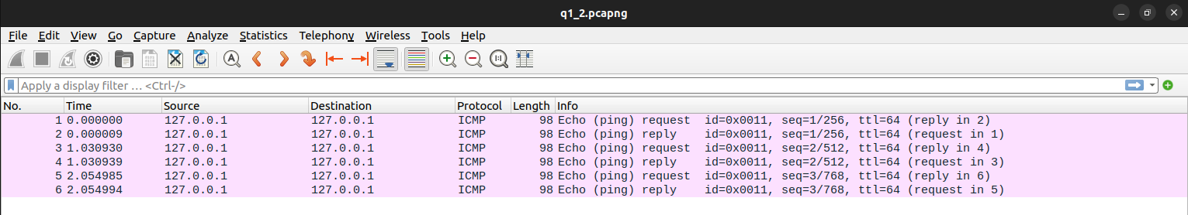

Q2.)
While tcpdump host your_host is running to capture traffic from your machine, execute telnet 128.238.66.200. Note there is no host with this IP address in the current configuration of the lab network. Save the tcpdump output of the first few packets for the lab report. After getting the necessary output, terminate the telnet session. From the saved tcpdump output, describe how the ARP timeout and retransmission were performed. How many attempts were made to resolve a non-existing IP address?

sudo tcpdump host 172.16.59.52

telnet 128.238.66.200
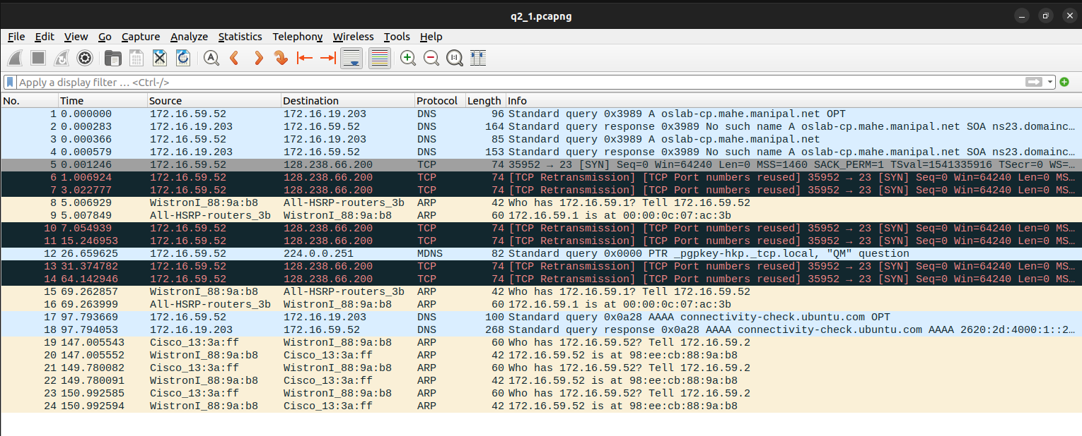
You will notice 6 total ARP attempts, each at 1 second from the previous.

sudo tcpdump host 172.16.59.52

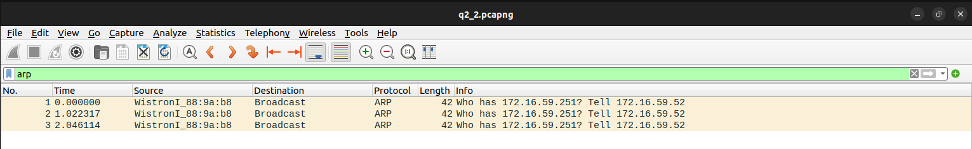
ping 172.16.59.251 -c 1
Since the destination IP is outside the LAN, it is observed that the request is communicated to the main lab router. It is noticed that the TCP Retransmissions follow the following pattern: The delay between 2 retransmissions increases by a factor of 4 after every attempt. (T2 - T1 = 2, T3 - T2 = 8, T4 - T3 = 32)

Q3)
Briefly explain the purposes of the following tcpdump expressions.
a. tcpdump udp port 520
b. tcpdump -x -s 120 ip proto 89
c. tcpdump -x -s 70 host ip addr1 and (ip addr2 or ip addr3)
d. tcpdump -x -s 70 host ip addr1 and not ip addr2

a. `tcpdump udp port 520`:
This expression captures UDP packets that are destined for port 520.

b. `tcpdump -x -s 120 ip proto 89`:
This expression captures IP packets with protocol number 89. The `-x` flag tells `tcpdump` to display packet contents in hexadecimal and ASCII. The `-s 120` flag limits the capture to 120 bytes of each packet.

c. `tcpdump -x -s 70 host ip addr1 and (ip addr2 or ip addr3)`:
This expression captures packets sent to or from `ip addr1` and either `ip addr2` or `ip addr3`. The `-x` flag displays packet contents in hexadecimal and ASCII, and the `-s 70` flag limits each captured packet to 70 bytes.

d. `tcpdump -x -s 70 host ip addr1 and not ip addr2`:
This expression captures packets sent to or from `ip addr1` but excludes packets that involve `ip addr2`. The `-x` flag displays packet contents in hexadecimal and ASCII, and the `-s 70` flag limits each captured packet to 70 bytes.

Q4)
4. Basic packet decoding
1) Write a tcpdump command to dump network traffic from an Ethernet connection to the
screen in human readable output format. Perform the following operation and write down
the observations.
a) Capture all the traffic of maximum snap length of 65,535 bytes and provide the
hexadecimal and ASCII decodes of all the traffic in each packet.
b) Find the IP addresses, IP packet length, TCP port numbers, TCP flags, etc. by using the reference chart to locate those fields on the hexadecimal dump.

Command Used :
sudo tcpdump -ttttnnvS -i enp2s0

a.)
sudo tcpdump -x -s 65535 -ttttnnvS -i enp2s0
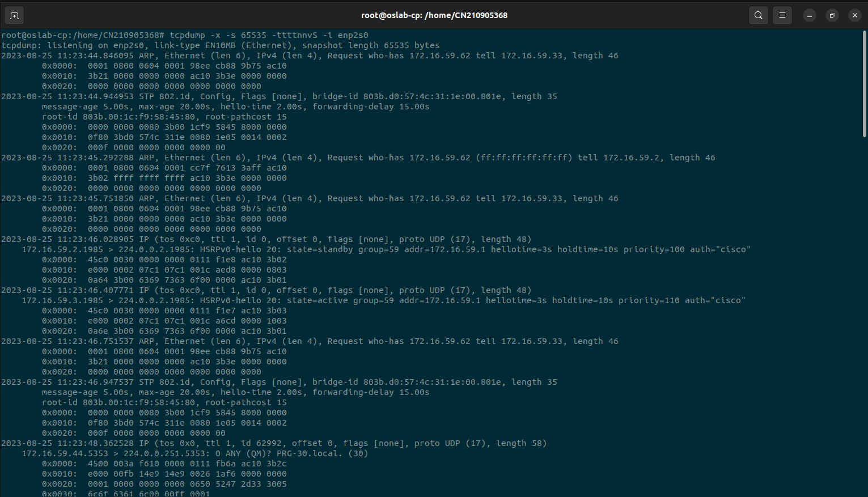

b.)

Source IP : 172.16.59.52
Destination IP : 34.107.221.82

IP Packet Length : 60

Source Port : 40598
Destination Port : 80

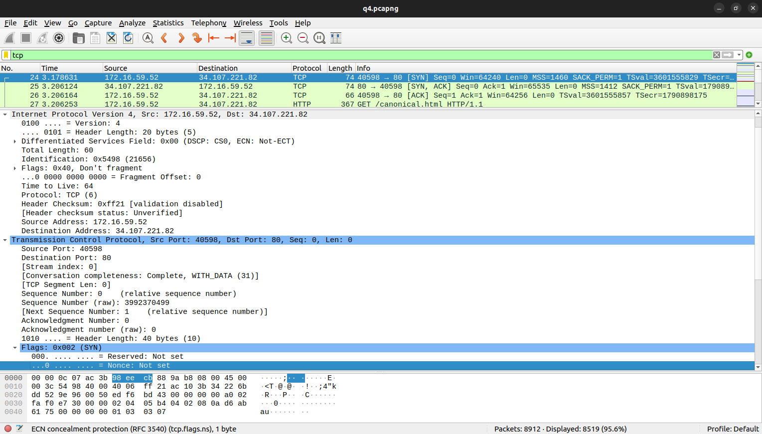

TCP Flags :

